USER INTERFACE AND DESIGN

COMAPARSION OF UI DESIGN BETWEEN TWO FIGMA CREATION

NAME : SHALINI R K ROLL NO:230701304

BAD WEBSITE:

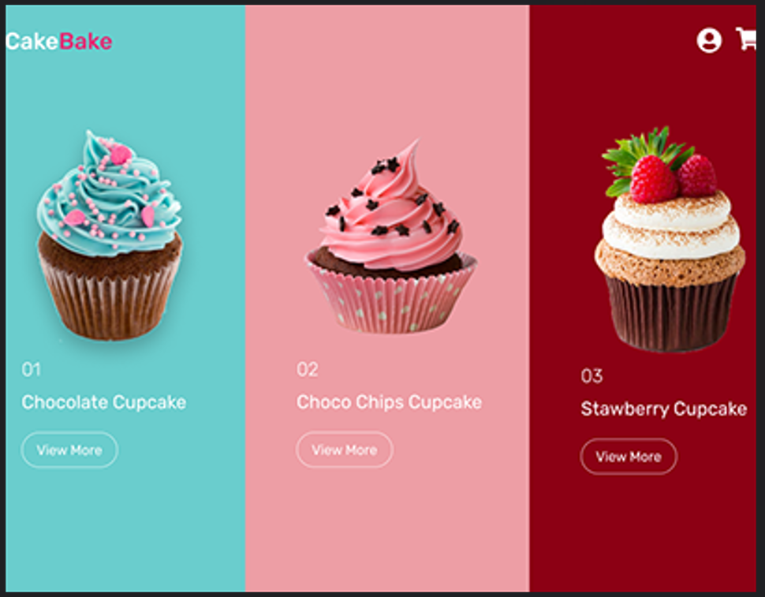

GOOD WEBSITE:

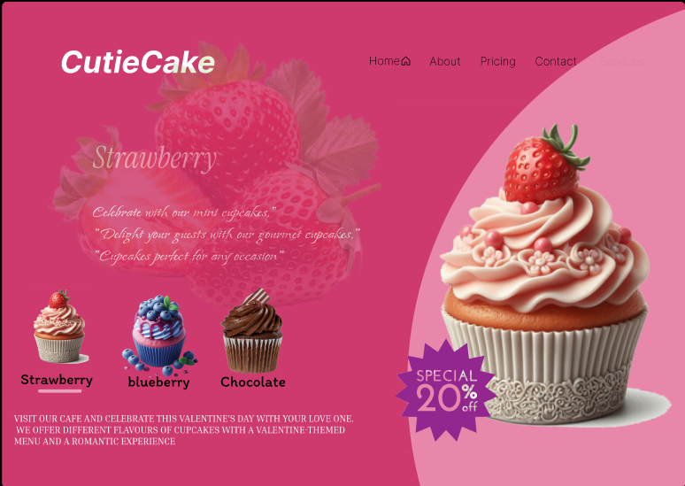

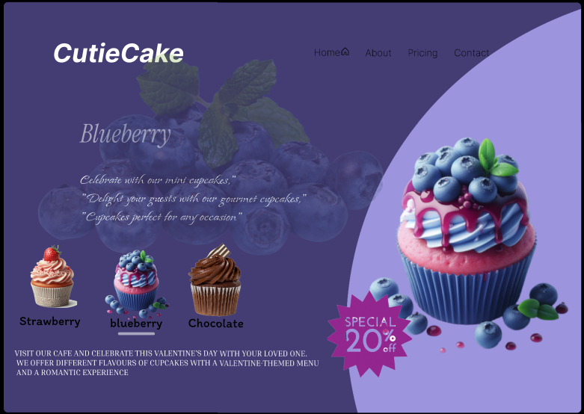

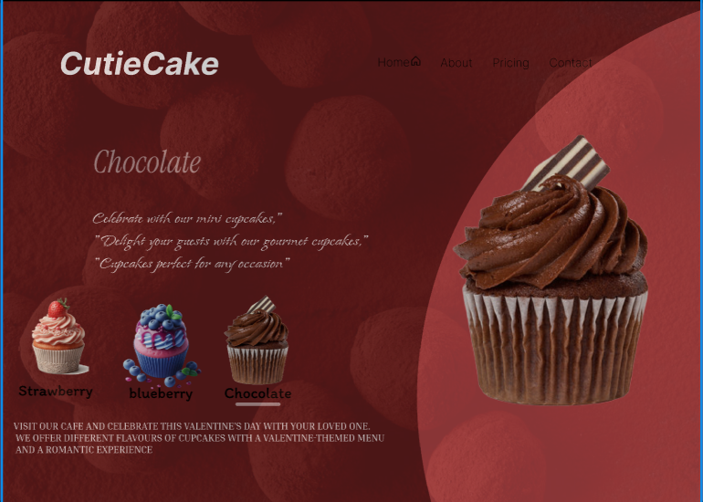

PROTOTYPE LINK:

<https://www.figma.com/proto/ECuDKoHOk3zVAzyJFuw7EJ/website-1?page-id=0%3A1&node-id=25-286&p=f&viewport=-661%2C116%2C0.2&t=GrsGiob7eKzLua5y-1&scaling=min-zoom&content-scaling=fixed&starting-point-node-id=25%3A286>

**BAD WEBSITE (CakeBake)**

1. **Design Style:**
   * Minimalistic and clean layout.
   * Focused on showcasing cupcakes with large, colorful images.
   * Uses vibrant and contrasting background colors (turquoise, pink, maroon) for different cupcake categories.
2. **Content:**
   * Displays three cupcake varieties with their names and a “View More” button.
   * Content is direct and concise.
3. **Navigation:**
   * A minimalist navigation bar with icons (e.g., cart and user profile).
4. **Purpose:**
   * Likely designed for e-commerce or product browsing.

**GOOD WEBSITE (CutieCake)**

1. **Design Style:**
   * More elaborate, with a themed and artistic layout.
   * Each section highlights a specific flavor (Strawberry, Blueberry, Chocolate) with matching visuals and colors.
   * A soft and playful vibe, with background patterns and imagery complementing the cupcake flavor.
2. **Content:**
   * Includes descriptive text about each cupcake flavor, emphasizing celebration and special occasions.
   * Features a “Special 20% Off” promotional offer.
3. **Navigation:**
   * A broader navigation menu at the top, including links to Home, About, Pricing, and Contact.
4. **Purpose:**
   * Appears to focus on branding and creating an engaging experience, possibly for a bakery or café.

**Key Differences:**

* **Focus:** The first website is product-centric, while the second emphasizes storytelling and branding.
* **Design Aesthetics:** The first is simple and functional; the second is thematic and visually rich.
* **Content Depth:** The second provides more detail and promotional content, whereas the first focuses on simplicity.
* **Target Audience:** The first seems tailored for online shopping; the second is for building brand connection and promoting offers.